

Introduction to Web Technologies

**Project Documentation**

Teacher: Nataliia Strukalo

Student: Kudakwashe Nyamutsaka

ID: w67040

Rzeszów 2023

TABLE OF CONTENTS

* HOME PAGE
* PRODUCTS PAGE
* ABOUT US PAGE
* CONTACTS PAGE
* PRODUCTS DETAILS PAGE(s)

**Description of topic, and objectives**

**HOME PAGE**

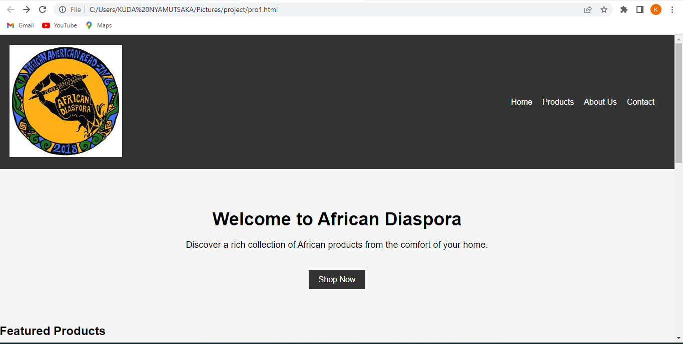

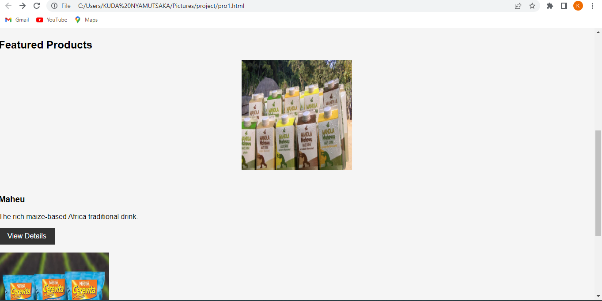

**PRODUCTS PAGE**

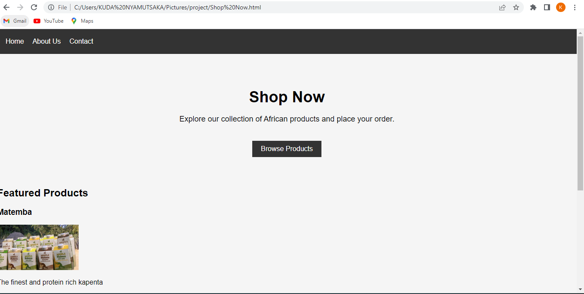

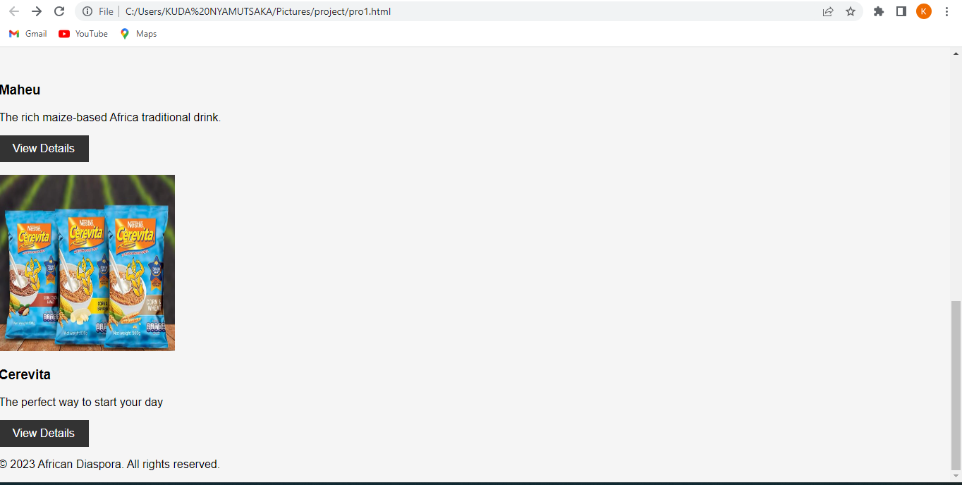

This is the page where customers can select all the products they are offering to purchase by viewing the product details and adding to cart if desired.

**PRODUCT DETAILS PAGE(s)**

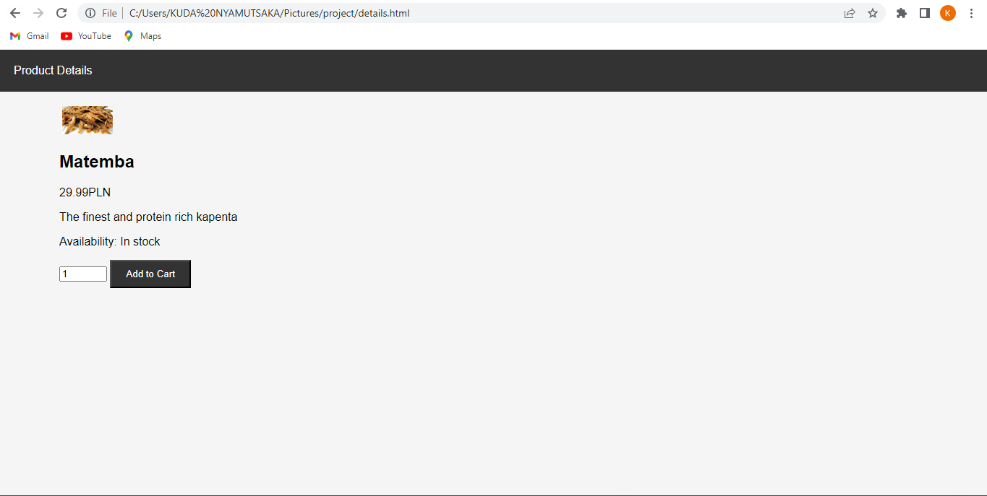

This page gives a short description of the product selected and gives option to add to cart.

**ABOUT US PAGE**

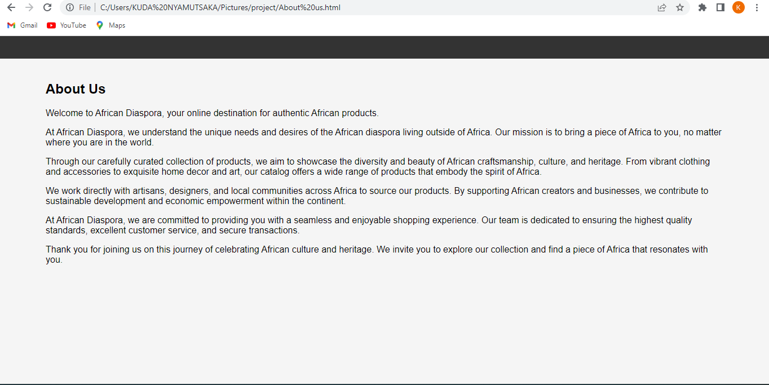

This page generally describes the aim of the creation of the website.

**CONTACTS PAGE**

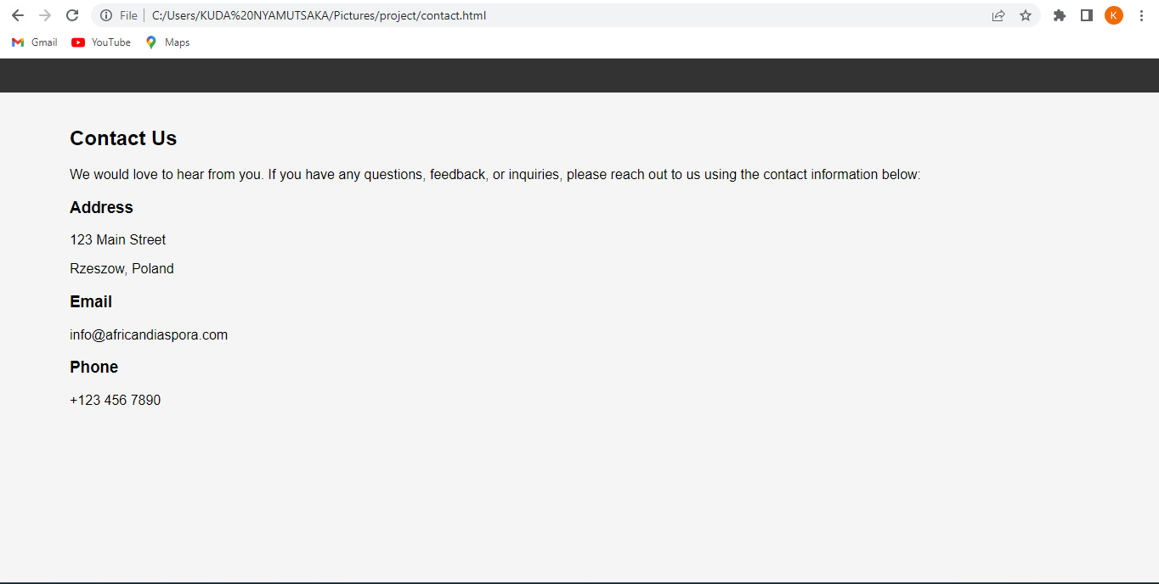

This page gives contact information for the African Diaspora team that will help and answer any questions about their products and website.

## DESCRIPTION OF THE TECHNOLOGIES USED

**LITERATURE**

* The website has a logo of "African Diaspora" displayed in the header section.
* The navigation menu consists of four links: Home, Products, About Us, and Contact.
* The main content is divided into two sections: a hero section and a product grid section.
* The hero section contains a heading, a brief description, and a call-to-action button to "Shop Now."
* The product grid section showcases featured products with their respective images, names, descriptions, and a "View Details" button for each product.
* The footer section includes a copyright notice with the year and the name "African Diaspora."